### Project-II

### BTCS 703-18

**BACHELOR OF TECHNOLOGY**

(Artificial Intelligence and Data Science.)



## SUBMITTED BY:

## AVIRAL SRIBASTAVA

## AYUSH

## AYUSH CHOUDHARY

## AVNY

## ROLL NO:

## 2420686

## 2420688

## 2420689

## 2420687

**Under the Guidance of**

Er. Shubham Sharma (J4224)

# Department of Artificial Intelligence and Data Science

# Chandigarh Engineering College Jhanjeri Mohali - 1040307

## Table of Contents

|  |  |  |
| --- | --- | --- |
| **S.No.** | **Contents** | **Page No** |
| 1. | Introduction | 1 |
| 2. | Brief Literature survey | 2 |
| 3. | Problem formulation | 3 |
| 4. | Objectives | 4 |
| 5. | Methodology/ Planning of work | 5 |
| 6. | Facilities required for proposed work | 6 |
| 7. | References | 7 |

**Introduction**

This project is about creating a smart helmet with IoT to help make riding two-wheelers safer. The helmet uses smart technology to keep an eye on the rider all the time, find accidents, and send help fast if something goes wrong. It also checks if the rider has drunk alcohol and stops the bike from starting if they have. It has a cooling system to make the helmet more comfortable so people wear it more.

The project comes from the high number of road accidents, especially with bikes. In India, around 180,000 people died in road accidents in 2024. Two-wheelers make up about 45% of these deaths. Things like not paying attention, speeding, and drinking alcohol cause many of these. This smart helmet wants to solve these problems with sensors and alerts. It links to the bike and a phone app to share location and health details.

In this synopsis, we first talk about the project's scope and background. Then, we review what others have studied. Next, we explain the problems and our goals. We also describe how we will do the work, what we need, and the references.

**Brief Literature survey**

Flow chart representation of the smart helmet model | Download Scientific Diagram

Smart helmets are getting popular as technology makes safety gear better. Studies show helmets with sensors can spot crashes and send alerts to emergency contacts right away. Some models use IoT for real-time location tracking. AI makes these systems more accurate than simple ones.

Main sensors include accelerometers and gyroscopes to detect falls or impacts. Advanced ones have cameras for spotting drowsy riders or road hazards. Microphones and GPS help with communication and tracking. Research also shows challenges like low power use, good alert systems, and right settings for alcohol sensors.

This project builds on these by using basic sensors with AI. It sets the base for future features like auto hospital alerts or image recognition.

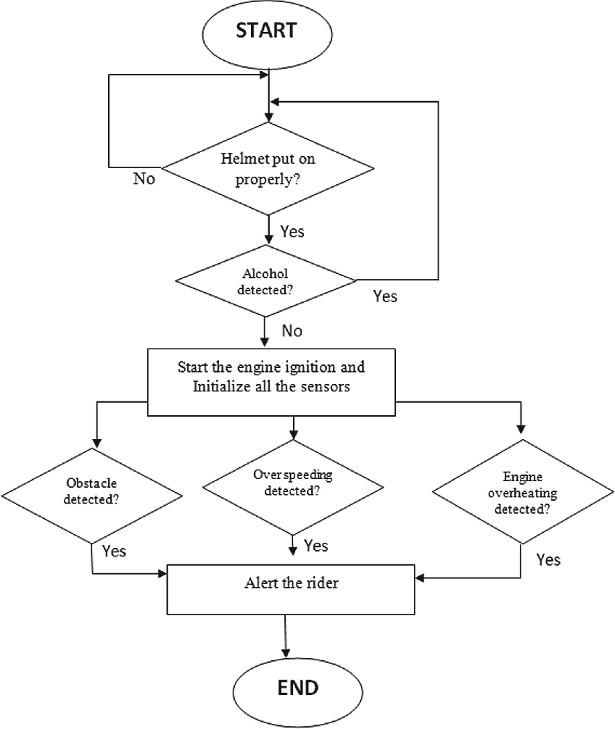

**Problem formulation**

Road accidents with two-wheelers are a major problem around the world. In India, over 180,000 people die in road crashes each year, and two-wheelers account for nearly 45% of those deaths. Key causes are rider errors, speeding, and alcohol use.

Emergency help often arrives too late, especially in remote spots, which can lead to more deaths. Many riders do not wear helmets because they feel uncomfortable or hot, even though helmets can prevent about 69% of head injuries. Drunk driving is still a big cause of accidents, and current ways like random police checks are not enough.

This project matters because it can lower these deaths by using technology to monitor riders, send quick alerts, stop drunk riding, and make helmets comfy. It could save lives and make roads safer

**Objectives**

The key goals of this project are:

* To make a smart helmet that checks rider safety, like spotting head impacts, environment, and rider actions.
* To create auto alerts that send GPS location to emergency contacts and services during accidents, to speed up help.
* To add controls that block the bike start if the rider is drunk or not wearing the helmet properly, to stop accidents.
* To boost comfort with a smart ventilation system in the helmet, so more riders use it.
* To build a mobile app and cloud system for real-time tracking of location, health, and updates.
* To test the helmet in real conditions to check if it works well, lasts, and users like it.

**Methodology/ Planning of work**

Project Plan Timeline Infographic Template - Venngage

We will do this project in steps to ensure it works well.

Phase 1: Design & Prototyping - Build and put together a full IoT smart helmet prototype with all sensors, communication, and safety parts. Test it in a lab to check basic work.

Phase 2: Emergency System Implementation - Improve accident detection and set up auto SMS alerts with GPS to contacts and local services.

Phase 3: Alcohol Detection Integration - Tune the alcohol sensor and connect it to the bike ignition, with checks to avoid wrong alerts while stopping drunk driving.

MQ-3 MQ3 Alcohol Sensor Module Breath Gas Detector Ethanol Detection For Arduino | eBay

Phase 4: Digital Interface Development - Make a full mobile app and cloud interface for tracking location, monitoring health, and setting up the system. Add remote checks and updates.

Phase 5: Power Optimization - Save power with good parts and add solar charging. Aim for at least 72 hours battery life in normal use.

Phase 6: Real-World Testing - Test a lot in different riding situations, weather, and traffic. Check how well it works, how strong it is, and if users accept it.

We will use cheap parts like Arduino boards for control, and software for the app.

**Facilities required for proposed work**

To build and test this, we need:

* Hardware: Sensors (alcohol, accelerometer, GPS, fan), microcontroller boards, helmet base, solar panels, batteries, and bike ignition setup.
* Software: Coding tools (like Arduino IDE), app development (Android Studio), cloud services (like AWS or Firebase).
* Lab space: For building and testing, with safety tools and equipment like multimeters.
* Testing area: Safe places for real tests, like quiet roads or tracks.

Computers: For designing, coding, and looking at data.

# REFERENCES

What is a Smart Traffic Management System? | Symmetry Electronics

1. Bhardwaj, P., et al., 2025. "Development of an AI-Integrated Smart Helmet for Motorcycle Riders' Safety Enhancement", PMC, <https://pmc.ncbi.nlm.nih.gov/articles/PMC11846507/>.
2. Singh, A., et al., 2024. "Development of Smart Helmet using Internet of Things (IOT)", ResearchGate, <https://www.researchgate.net/publication/382090929_Development_of_Smart_Helmet_using_Internet_of_Things_IOT>.
3. Kumar, R., et al., 2025. "IOT Smart Helmet System for Delivery Rider Safety", Journal of Engineering Research and Reports, Vol. 27, No. 6, pp. 236-245.
4. Patel, S., et al., 2024. "IoT-Enabled Smart Helmet System for Enhanced Road Safety and Accident Detection", IEEE Xplore.
5. Gomez, J., et al., 2023. "Internet of Things-Based Smart Helmet with Accident Identification and Communication for Delivery Riders", MDPI, <https://www.mdpi.com/2673-4591/58/1/129>.
6. Chen, L., et al., 2022. "Trends in Smart Helmets With Multimodal Sensing for Health and Safety: Review and Perspectives", PMC, <https://pmc.ncbi.nlm.nih.gov/articles/PMC9709670/>.

# 